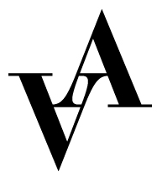

Application to Kammarmusik-Akademien
Vadstena-Akademien

Place: Vadstena

Please fill out this form and send it together with CV, cover letter and 2 relevant references with contact information to apply@vadstena-akademien.org no later than February 20, 2020.

Name:

Address:

Postal number:

City:

Country:

Email:

Phone:

Birth year:

Instrument:

Relevant education:

School:

Length of education:

Relevant projects within the area:

Previous experience:

References with contact information:

