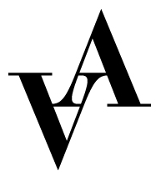

Application to costume assistant 2022
Vadstena-Akademien

Production: Breaking the Waves (2016) by Missy Mazzoli and Royce Vavrek or Il colore fa la regina by Carlo Francesco Pollarolo (1653-1723) and Matteo Noris (1640-1714).

Place: Vadstena slott, Vadstena and Vadstena Old Theatre.

Please fill out this form and send it together with CV, cover letter and 2 relevant references to apply@vadstena-akademien.org no later than February 25, 2022.

Name:

Address:

Postal number:

City:

Country:

Email:

Phone:

Birth year:

Education with costume:

School:

Length of education:

Relevant internships within the area:

Previous experience within costume:

References with contact information:

To which production and period are you applying:

